An

Industrial Training Report on

# Web Development

At

**InternPe**

*Submitted in partial fulfillment of the requirements for the award of the degree of*

## Bachelor of Technology

## in

**Department of Advance Computing**



**(Session 2023-24)**

**Submitted to:** **Submitted by:**

**Ms. Amritpal Kaur**  **Dherendra Tiwari**

(Coordinator: Industrial Training) PCE22CA014

Class: D (CSE(AI))

# DEPARTMENT OF ADVANCE COMPUTING

# POORNIMA COLLEGE OF ENGINEERING, JAIPUR

# RAJASTHAN TECHNICAL UNIVERSITY, KOTA

# SEPTEMBER, 2024

## DECLARATION

I hereby declare that the work which is being presented in the **Industrial Training** report titled Web Development in partial fulfillment for the award of the Degree of **Bachelor of Technology** in **Advance Computing** and submitted to the Department of **Advance Computing**, **Poornima College of Engineering, Jaipur**, is an authentic record of my own work carried out at **InternPe**, Jaipur during the session 2023-24.

I have not submitted the matter presented in this report anywhere for the award of any other Degree.



Signature of the Student:

Name: Dherendra Tiwari

Reg. No.: PCE22CA014

Place: Jaipur

Date: 30/8/2023

**Training Certificate from Company:**

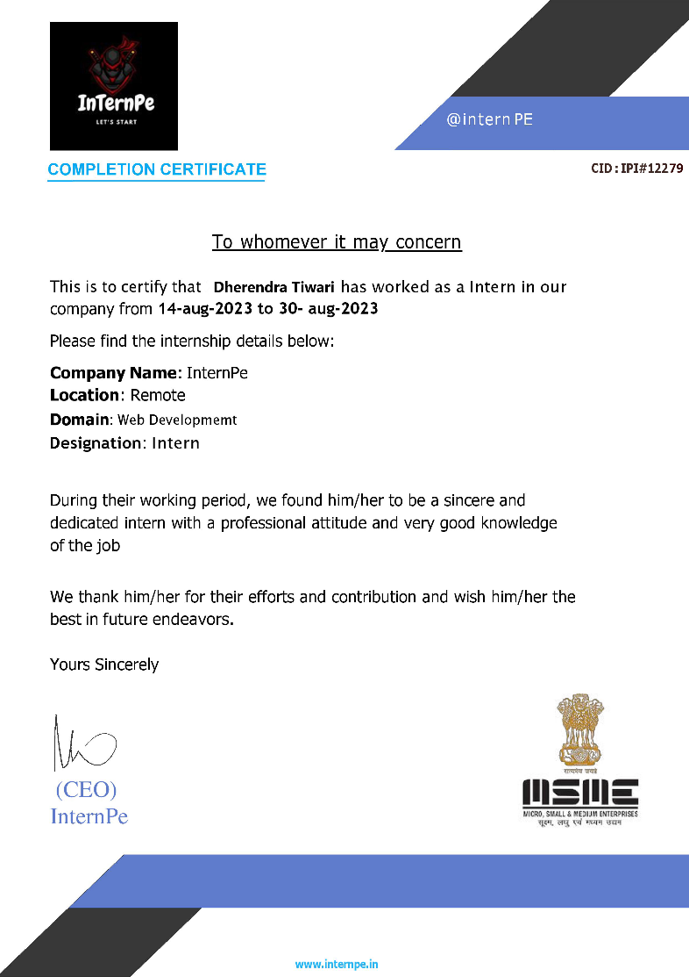



## DEPARTMENT OF ADVANCE COMPUTING

**Date: 30/8/2023**

# CERTIFICATE

This is to certify that Industrial Training report Full stack **Web Development** has been submitted by **Dherendra Tiwari**, **PCE22CA014** in partial fulfillment for the award of the Degree of Bachelor of Technology in Advance computing during the session 2023-24. The industrial training work is found satisfactory and approved for submission.

**Ms. Amritpal Kaur Dr. Kamlesh Gautam**

Professor& Head

Coordinator- Industrial Training Department of Advance Computing

## ACKNOWLEDGEMENT

I would like to convey my profound sense of reverence and admiration to my supervisor **Mr. Brij Awasthi CEO of InternPe** for his intense concern, attention, priceless direction, guidance and encouragement throughout this internship.

I extend my heartiest gratitude to **Ms. Amritpal Kaur** , Coordinator-Industrial Training, who extended their cooperation to steer the topic towards its successful completion.

My special heartfelt gratitude goes to **Dr. Kamlesh Gautam,** Head, Department of Advance Computing, Poornima College of Engineering, for unvarying support, guidance and motivation during the course of this research.

I am grateful to **Dr. Mahesh Bundele**, Director, Poornima College of Engineering for his helping attitude with a keen interest in completing this training work in time.

I would like to express my deep sense of gratitude towards management of Poornima College of Engineering including **Dr. S. M. Seth**, Chairman Emeritus, Poornima Group and former Director NIH, Roorkee, **Shri Shashikant Singhi**, Chairman, Poornima Group, **Mr. M. K. M. Shah**, Director Admin & Finance, Poornima Group and **Ar. Rahul Singhi**, Director Poornima Group for establishment of institute and providing facilities for my studies.

I am deeply thankful to my parents and all other family members for their blessings and inspiration. At last, but not least I would like to give special thanks to God who enabled me to complete my training work on time.

**Dherendra Tiwari**

**PCE22CA014**

**TABLE OF CONTENTS**

|  |  |  |
| --- | --- | --- |
| **S.no.** | **PARTICULARS** | **Page No.** |
| 1 | Title Page | 1 |
| 2 | Candidate’s Declaration | 2 |
| 3 | Training Certificate from Company | 3 |
| 4 | Certificate by the Department | 4 |
| 5 | Acknowledgment | 5 |
| 6 | Table of Contents | 6 |
| 7 | Abstract | 7 |
| 8 | Chapter 1: Introduction | 8 |
| 9 | Chapter 2: Technical Training Platform | 9 |
| 10 | Chapter 3: Overview of Technology Learn | 10 |
| 11 | Chapter 4: Project Description | 12 |
| 12 | Conclusion | 25 |
| 13 | References | 26 |

## ABSTRACT

**Full Stack Web development** is the work involved in developing a [website](https://en.wikipedia.org/wiki/Web_site) for the [Internet](https://en.wikipedia.org/wiki/Internet)[(World Wide Web)](https://en.wikipedia.org/wiki/World_Wide_Web) or an [intranet](https://en.wikipedia.org/wiki/Intranet) (a private network). Web development can range from developing a simple single [static page](https://en.wikipedia.org/wiki/Static_Web_page) of [plain text](https://en.wikipedia.org/wiki/Plain_text) to complex [web applications,](https://en.wikipedia.org/wiki/Web_application) [electronic businesses,](https://en.wikipedia.org/wiki/Electronic_business) and [social network services.](https://en.wikipedia.org/wiki/Social_network_service) A more comprehensive list of tasks to which Web development commonly refers, may include [Web engineering,](https://en.wikipedia.org/wiki/Web_engineering) [Web design,](https://en.wikipedia.org/wiki/Web_design) [Web content development,](https://en.wikipedia.org/wiki/Web_content_development) client liaison, [client-side](https://en.wikipedia.org/wiki/Client-side_scripting)[/server-side scripting,](https://en.wikipedia.org/wiki/Server-side_scripting) [Web server](https://en.wikipedia.org/wiki/Web_server) and [network security](https://en.wikipedia.org/wiki/Network_security) configuration, and [e-commerce](https://en.wikipedia.org/wiki/E-commerce) development.

Technologies used in Web development HTML, CSS, JavaScript are mainly used to develop the frontend along with various JS frameworks like Vue, React, Angular and many more, out of these you can choose any framework to work on the frontend of your website.

Moving on to the backend of the website, which is responsible for storing user data, session cookies, caching and many more. In the backend we use a database like

MongoDB or GraphQL to store user data. API’s are used to connect website to database and to call data back from database to website.

## CHAPTER 1 INTRODUCTION

**1.1 About Company:**

**InternPe** is a leading web development company in Jaipur that has a wide range of services such as web design, development and digital marketing. We Do- Listen, plan, implement and test - our experienced team delivers high quality, affordable web and mobile app solutions all over the globe.

**1.2 Training Platform:** *Vs Code*

**1.3 Training Starting Date:**

14-08-2023

**1.4 Training Ending Date:**

30-08-2023

**1.5 Total Training Duration:**

2-Weeks

**1.6 Date of Certification:**

30-08-2023

**1.7 Conclusion:**

Given, students can pass the criteria to enter companies to get real world experience; it is a really great opportunity. It was really great working with the Ui system team. Got to learn a lot along with great career guidance.

## CHAPTER 2 TECHNICAL TRAINING PLATFORM

**2.1 Introduction:**

***InternPe***, a Jaipur based IT company started by Founding CEO Mr. Brij Awasthi **by InternPe**aims to provide the Best Quality and Affordable Training to IT students in various IT Courses.

**2.2 Reason for selecting this platform:**

InternPe, as mentioned before is a Company lead by some great people and has an excellent team. They provide a lot of opportunities to learn in development field and then exploring that field under the guidance of people who already have the much-required knowledge and experience to guide new people to the field like me.

**2.3 Conclusion:**

It was a gratifying experience to work at InternPewith a lot of great people who guided me throughout my internship. I started as a beginner in web development at InternPe. By the end of my internship, I got to know that I want to explore the field of frontend engineering and it is great to know what you want to do in the coming future and have set life goals for yourself.

## CHAPTER 3Overview of Technology Learnt

**List of Technology Learnt**

**3.1 Hyper Text Markup Language**

**3.2 Cascading Style Sheets**

**3.1Hyper Text Markup Language**

HTML is the Standard Markup Language. It is used for developing Web Pages. HTML is Hyper Text Markup Language and is used for describing the structure of web pages. It is a series of nested tags that contain all the website information (like texts, images and videos).

The HTML defines the page structure.

**More About HTML5:**

* HTML5 gives developers more control over the performance of their websites
* It supports audio and video controls with the use of <audio> and <video> tags.
* HTML5 has new content related elements, like, <header>, <footer>, <article>, <section>, <nav>, etc.
* You can use HTML5 with all new browsers.
* HTML5 language is more mobile-friendly.
* Html5 uses cookies to store data.
* It supports local storage

A code sample of HTML

<!DOCTYPE html>

<**html**>

<**head**>

<**title**> My First Website </**title**>

</**head**>

<**body**>

<**p**>Welcome to HTML5, CSS3 and JavaScript! </**p**>

</**body**>

</**html**>

**3.2 Cascading Style Sheets**

Cascading Style Sheets, fondly referred to as CSS, is a simple design language intended to simplify the process of making web pages presentable.

CSS handles the look and feel part of a web page. Using CSS, you can control the color of the text, the style of fonts, the spacing between paragraphs, how columns are sized and laid out, what background images or colors are used, layout designs, variations in display for different devices and screen sizes as well as a variety of other effects.

CSS is easy to learn and understand but it provides powerful control over the presentation of an HTML document. Most commonly, CSS is combined with the markup languages HTML or XHTML.

{

color: blue; /*a comment */ text-align: center; margin: 10px; font: 14px Tahoma;

}

## CHAPTER 4PROJECT DESCRIPTION

List of Projects

4.1 CV

4.2 Contact Us

## 1.CV

<!DOCTYPE html>

<html lang="en">

  <head>

    <meta charset="UTF-8" />

    <meta http-equiv="X-UA-Compatible" content="IE=edge" />

    <meta name="viewport" content="width=device-width, initial-scale=1.0" />

    <link rel="stylesheet" href="style.css" />

    <title>Calculator - By Code Traversal</title>

    <style>

        @import url('https://fonts.googleapis.com/css2?family=Poppins:wght@500&display=swap');

  </style>

  </head>

  <body>

    <div class="container">

      <div class="calculator">

        <input type="text" id="inputBox" placeholder="0" />

        <div>

          <button class="button operator">AC</button>

          <button class="button operator">DEL</button>

          <button class="button operator">%</button>

          <button class="button operator">/</button>

        </div>

        <div>

          <button class="button">7</button>

          <button class="button">8</button>

          <button class="button">9</button>

          <button class="button operator">*</button>

        </div>

        <div>

          <button class="button">4</button>

          <button class="button">5</button>

          <button class="button">6</button>

          <button class="button operator">-</button>

        </div>

        <div>

          <button class="button">1</button>

          <button class="button">2</button>

          <button class="button">3</button>

          <button class="button operator">+</button>

        </div>

        <div>

          <button class="button">00</button>

          <button class="button">0</button>

          <button class="button">.</button>

          <button class="button equalBtn">=</button>

        </div>

      </div>

    </div>

    <script >

        let input = document.getElementById('inputBox');

let buttons = document.querySelectorAll('button');

let string = "";

let arr = Array.from(buttons);

arr.forEach(button => {

    button.addEventListener('click', (e) =>{

        if(e.target.innerHTML == '='){

            string = eval(string);

            input.value = string;

        }

        else if(e.target.innerHTML == 'AC'){

            string = "";

            input.value = string;

        }

        else if(e.target.innerHTML == 'DEL'){

            string = string.substring(0, string.length-1);

            input.value = string;

        }

        else{

            string += e.target.innerHTML;

            input.value = string;

        }

    })

})

  </script>

</html>

*{

    margin: 0;

    padding: 0;

    box-sizing: border-box;

    font-family: 'Poppins', sans-serif;

}

body{

    width: 100%;

    height: 100vh;

    display: flex;

    justify-content: center;

    align-items: center;

    background: linear-gradient(45deg, #0a0a0a, #3a4452);

}

.calculator{

    border: 1px solid #717377;

    padding: 20px;

    border-radius: 16px;

    background: transparent;

    box-shadow: 0px 3px 15px rgba(113, 115, 119, 0.5);

}

input{

    width: 320px;

    border: none;

    padding: 24px;

    margin: 10px;

    background: transparent;

    box-shadow: 0px 3px 15px rgbs(84, 84, 84, 0.1);

    font-size: 40px;

    text-align: right;

    cursor: pointer;

    color: #ffffff;

}

input::placeholder{

    color: #ffffff;

}

button{

    border: none;

    width: 60px;

    height: 60px;

    margin: 10px;

    border-radius: 50%;

    background: transparent;

    color: #ffffff;

    font-size: 20px;

    box-shadow: -8px -8px 15px rgba(255, 255, 255, 0.1);

    cursor: pointer;

}

.equalBtn{

    background-color: #fb7c14;

}

.operator{

    color: #6dee0a;

}

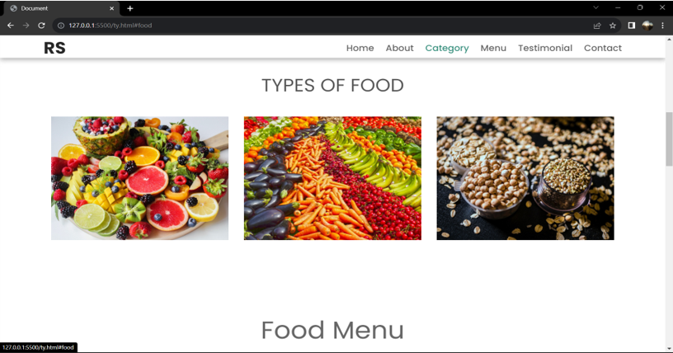

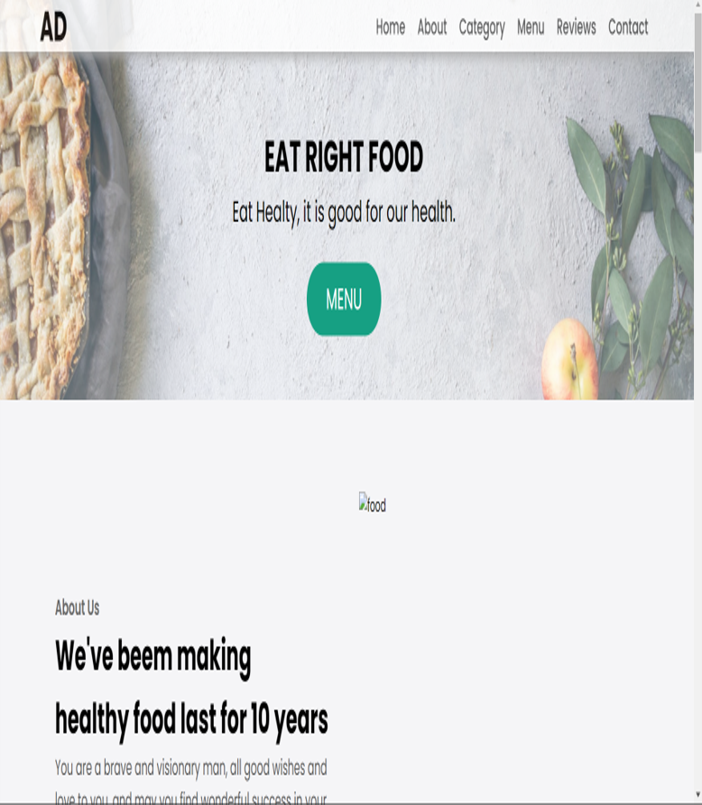

# Conclusion

The internship brought a lot of opportunities of developing myself from the perspective of career building.

It provided not only technical skills but also an experience of working environment in companies and the soft skill development part.

The skills learnt are as follows-

o Front end Web Development o Communication Skills

o Working in Group

With the wholesome time duration of internship and the completion of project the time constraint flaw still plays in the corner. If the duration of the internship was a bit longer, then there would have been a lot of learning, a lot more experiences and a lot more achievements as well as experiments.

The recommendation for the same would to extend the time duration of internship period so that the learning could be enhanced and increased.

**REFERENCES**

* <https://codepen.io/>
* <https://developer.mozilla.org/en-US/>
* <https://www.w3schools.com/>
* <https://colorhunt.co/>
* <https://devdocs.io/>